Convocation & Diploma Awarding Ceremony - 2017

The Annual Convocation & Diploma Awarding Ceremony of the University of Vocational Technology will be held on the 21st December 2017 at BMICH.
Those who have successfully completed the courses are requested to return the duly completed relevant annex, to the undersigned by registered post or fax (0112630705) on or before 15.11.2017.
The lists of names of those who have successfully completed the above courses are available in the official website of the University of Vocational Technology.

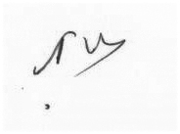
Director General
University of Vocational Technology

